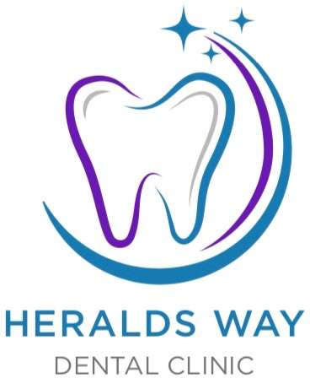

Our COVID-19 Safety Protocol
Your patient experience may now be slightly different to what you have been accustomed to. We have implemented some additional safety measures to ensure our staff and patients are well protected at all times.

Pre-appointment
We’ll verify information over the phone and update your medical history before your appointment. We have a Patient Portal system in place which allows patients to complete treatment forms and send them back to us before attending your appointment.

Arrival etiquette
We are trying to limit the number of people in the practice at any one time so please ensure you arrive at precisely your appointment time. Please come alone unless unable to do so and carry only essential belongings.

Social distancing
We will continue to encourage social distancing wherever possible.

Protective screens
You’ll notice that we’ve installed a clear Perspex screen at the front of our reception. This is a further precautionary measure for interaction at the desk.

Maintain essential hygiene
We will ask you to clean your hands as you enter the practice using the antibacterial gel provided. You will also be asked to wash your hands once in the surgery.

PPE
If possible, please arrive with your own face mask. Although not a mandatory requirement any longer, we request that patients respectfully wear one while in the waiting room in order to protect our vulnerable staff/patient.

More frequent, deeper cleans
Our cross-infection protocols have always been at the very highest standards but we have allowed even more time between patients to make sure nothing is overlooked

.

